Name: ____________________

L.T. AA0: I can use my presumed knowledge Review

**I can solve equations 10 8.5 7.5 5**

1.) $2x+8=16-6x$

2.) $\frac{4x+6}{9}+5=10$

3.) (x + 4)(x – 9) = (x + 3)(x + 5)

**I can solve systems 10 8.5 7.5 5**

1. -3x +2 y = 12

y = 5x – 1

1. 2y – x = -5

x = y + 4

1. Tory solved a system of equations below. Did she do it correctly? How do you know? If she did not, find her errors and solve the system correctly.

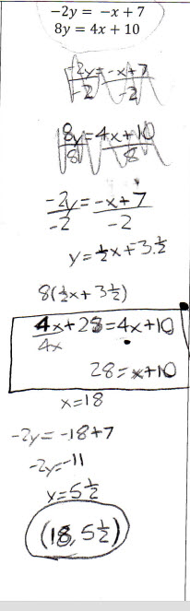

**I can evaluate equations in function form 10 8.5 7.5 5**

1. For each of the following relations find the missing values. If no value exists explain why it does not.
   1. f(x) = -2(x + 5), find f(-4) c. f(x) = $2+\sqrt{x+5}$, find f(-6)
   2. f(x) = x4, f(x) = 256, find x

1. Find the corresponding inputs or outputs for the following relations. If there is no solution, explain why not. Be careful: In some cases, there may be no solution or more than one possible solution.  
   a. f(x) = x3, find f(-8) c. f(x) = , find f(6)

b. f(x)= -2x2 + 10, f(x) = -40, find x

1. Examine the functions below and evaluate

F(x) = -x2 + 6 G(x) = 3x + 4 3

a. f(-2) b. f(n) c. f(4) + g(-8)

**I can decide whether or not a relation is a function and I can find the domain and range of a relation 10 8.5 7.5 5**

1. Compare the inputs and outputs of each relation below and decide if the relation is or is not a function. Then find the domain and range.

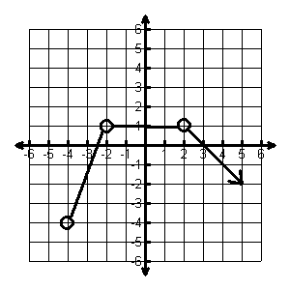 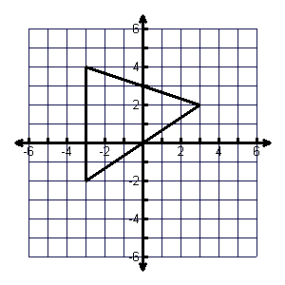

1. Examine the graph below and answer the following questions
2. Describe the domain and range
3. Is the graph a function? How can you tell?
4. Name any special points (i.e. intercepts, minimums, maximums, etc.)
5. Find F(4)

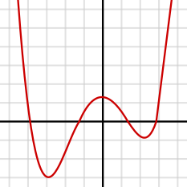

1. Sketch the graph of a relation that is not a function. Explain why it is not a function.

**I can solve quadratic equations 10 8.5 7.5 5**

1. Examine each quadratic equation below and decide which strategy (Factoring or the Quadratic Formula) is best to try. Write justifications for why you chose each method.
2. 0 = 2x2 – 3x + -20 b. 0 = 4x2 + 10x – 25
3. Solve for x: (x + 4)(x2 + x – 1) = 0