Name: ______________
D8 - HW
- Write the equation for the graph below

- Write the equation for the graph below
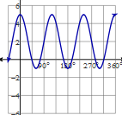

- Write the equation for the graph below
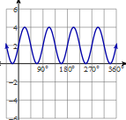

- Write the equation for the graph below

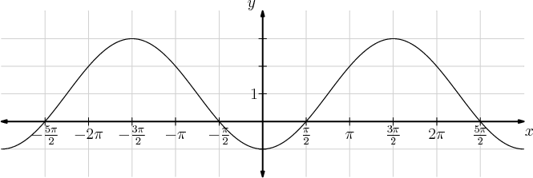
- Write the equation for the graph below

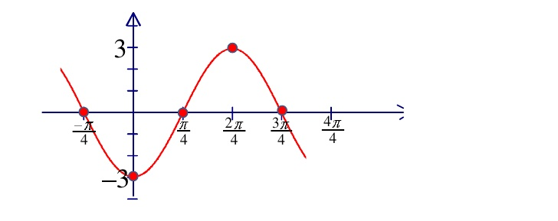
- Graph your own equation and then explain how you would identify the values you would need for the equation.
