Name:_________________________________________per.______ GEOMETRY; Tuesday; Feb. 21st
Slopes & Quadrilaterals
D6 HW = Review for Quiz

1. C-Quality  Consider quadrilateral WXYZ with vertices W(–2, 3), X(–1, 8), Y(9, 6), and Z(8, 1).  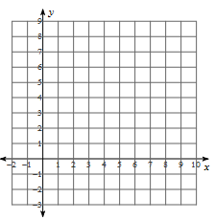 | Is this quadrilateral a parallelogram? A trapezoid? A rectangle? A rhombus? A square?  Justify your answer using slopes and distances.  Area: ____________  Perimeter: _______
2. B-Quality  Consider quadrilateral STUV with vertices S(0, 2), T(2, 6), U(6, 4), and V(2, 1). | How many right angles does STUV have? Justify your answer using slopes.  Prove that STUV  is a trapezoid.  Area: _________  Perimeter: ______
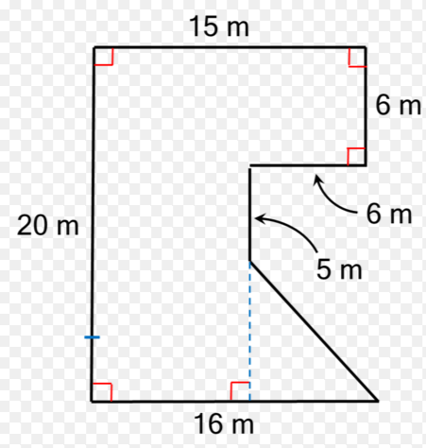
3. A – Quality
Can you determine the perimeter of this composite shape?
If yes—do it. If no, state why not.

Can you determine the area of this composite shape?
If yes—do it. If no, state why not.

