Algebra 3 – 4 Homework – All work must be done on a separate sheet of paper.
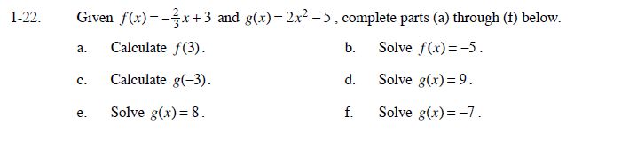
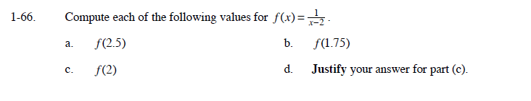
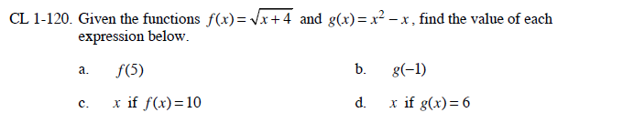

Algebra 3 – 4 Homework – All work must be done on a separate sheet of paper.

