Day 4 HW – Geometry Name:________________________________________per.___
C-Quality
Mark everything that is true about a rhombus’ sides & diagonals. Then, describe any angle relationships. 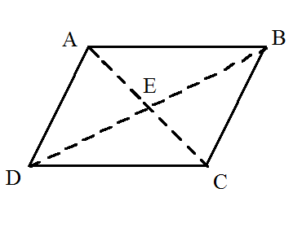If angle ABE = 33 degrees, what are all the other angles?

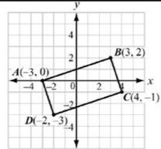
B-Quality

What is the name of this shape?

Find the Length of AB:

What is the Perimeter?

What is the Area?

A-Quality (hint: You’ll need trig here)

Find the missing values:

Find the Perimeter: Find Area:

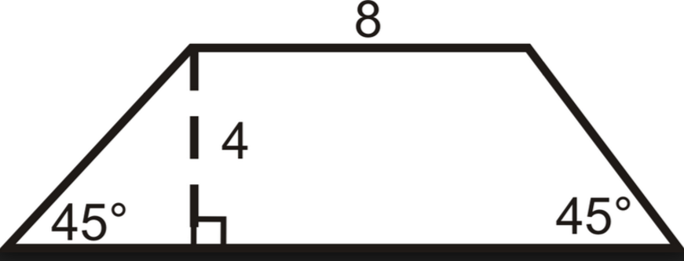
C-Quality  Plot and connect the points. What kind of triangle is NOD? Justify your answer.  $$N\left(-1, 3\right), O\left(1, 7\right),D(5, 2)$$  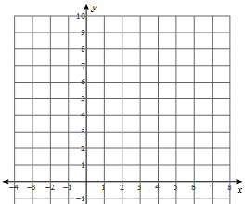 | NO = _______________  DO = _______________  ND = _______________  Area: ______  5 pts  Perimeter: __________
B-Quality  Plot and connect the points $A\left(1, 4\right), B\left(6, 6\right), C\left(4, 1\right), D(-1, -1)$ to make quadrilateral ABCD. Find the values at right and then explain why it is rhombus.  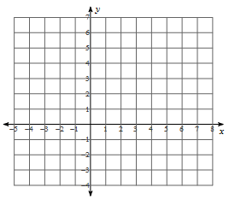 | AB = ______________  BC = ______________  DC = ______________  AD = ______________  Area: ______  5 pts  Perimeter: __________
A-Quality  Plot and connect the points $M\left(1, 5\right), A\left(5, 7\right), T\left(7, 3\right), D(3, 1)$ to make quadrilateral MATH. Answer the questions at right.  MA = _______________  AT = _______________  HT = _______________  MH = ______________  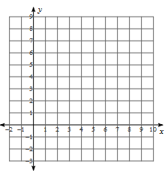 | What is the best name for the shape of MATH? Justify your answer.  Area: ______  5 pts  Perimeter: __________

