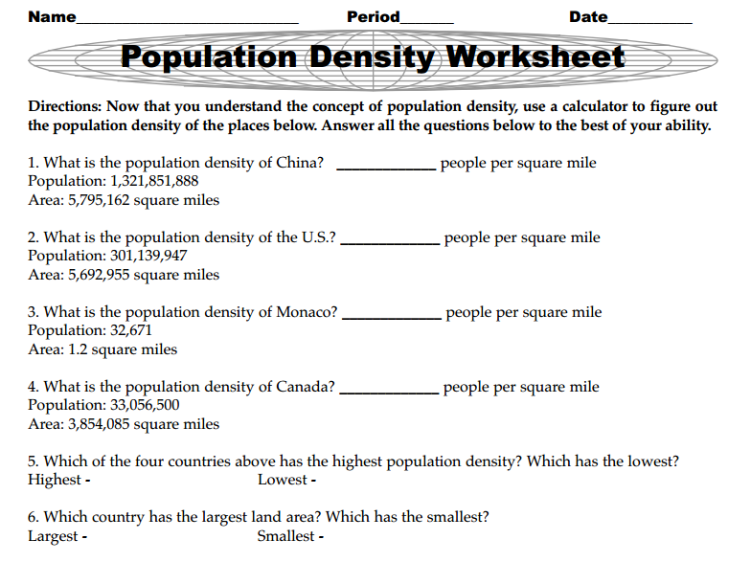
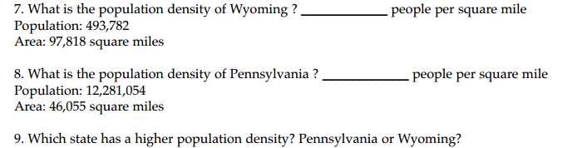

10. Based on the map on the back what city appears to have the highest population density?

11. What city appears to have the lowest population density?

