D3 Geometry Homework Name: ______________________
Homework: Complete the necessary calculations but show your work and circle your answer for credit.
Section 1: Choose three problems in each section. Find the volume of each figure after naming the shape
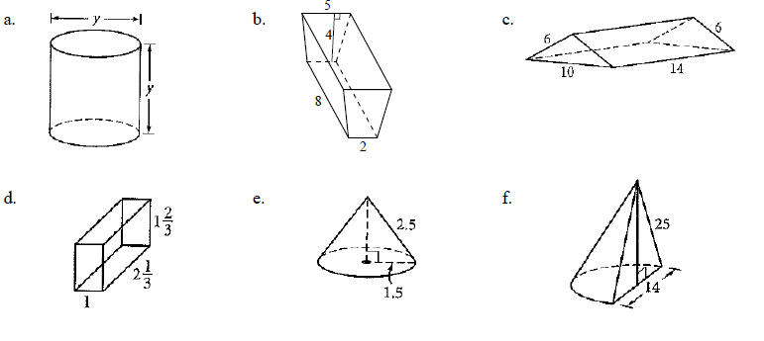

Section 2: Choose two problems and show ALL work. Circle your final answer.
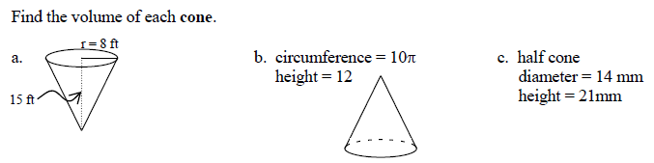

Section 3: Choose three problems in each section. Find the volume of each figure after naming the shape
