Day 3 - Homework for Properties of Quadrilaterals
Name:
Solve for the variables.
1)
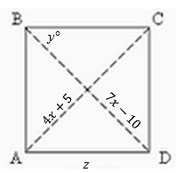
2)
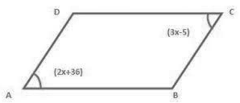
3)
(3x – 5)°
(2x + 36)°
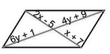
4) Solve for x in the rhombus below.
4)
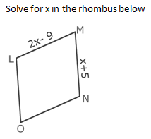
5) In the rectangle below, find CT, HA, AT, and MA
Then find the perimeter and area of the rectangle.
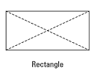

C
24
H
T
13
A
M

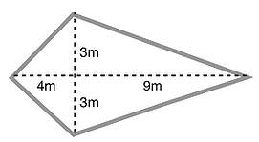
6)
y
z
x

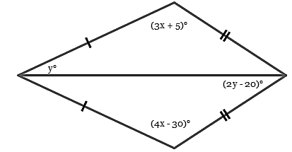
7)

8) In a trapezoid, consecutive angles are supplementary (because of same side interior angles).
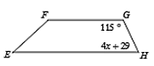
>
>

C
B
9) In an isosceles trapezoid, base angles are congruent (because of HL $≅$).
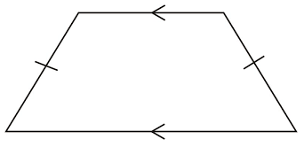

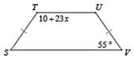
If you draw two perpendicular heights from BC to AD, you create two triangles, ΔABF and ΔDCE, that are congruent by HL $≅$.
So, ∠A $≅$∠D, by CPCTC.
F
E
D
A
>
>

