E# Volume & Surface Area: CLASSWORK
8.7 The student will investigate and solve practical problems involving volume and surface area of prisms, cylinders, cones, and pyramids.

Name___________________________ Date__________ Block________

Find the Surface Area and Volume for each figure…

- Surface Area =_______ Volume = _______

7in

21 in

- Surface Area =_______ Volume =_______
9ft

6ft
18 ft

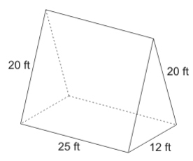

Surface Area =_______ Volume =_______

- Thelma and David built a recycling bin that is 6 feet wide, 12 feet long, and 14 feet high. How much trash can fit inside of the bin?

- The cylindrical canister of a fire extinguisher has a radius of 4 inches and is 12 inches high. How many cubic inches can it hold?

- Josh is wrapping a box that is 5 feet long 14 feet wide and 3 feet tall with wrapping paper. How much wrapping paper will he need to cover the box?

- Adam is building a rectangular planter without a top. The planter will be 7 inches wide, 16 inches long, and 10 inches high. How much wood is needed to make the bottom and sides of the planter?

