AA6 Day 10 Remainder and Factor Theorem Homework - SHOW all work on a separate sheet of paper or I will not give you credit
1. | 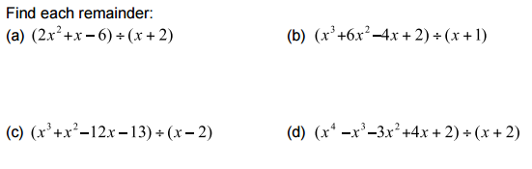
2.
3.
AA6 Day 10 Remainder and Factor Theorem Homework - SHOW all work on a separate sheet of paper or I will not give you credit
1.
2.
3.

