Name:_______________________________________per._____ GEO: Monday, March 27th - Prisims
1. What was most MEMORABLE about Spring Break? Write at least ten word OR draw a Picture. | 2. This week includes_____________________. What are your upcoming priorities?
1. Label dimensions and find the surface area & volume of a rectangular prism with length of 8 in, width of 3 in and height of_________ in. | Write the formula below for each of the following; then calculate the results.  SA = ___________________________  Volume =_______________________
2. A Square-Based Prism has a volume of approximately 614.125 inches^{3.} Draw a diagram and determine the lengths of all three sides. When complete, determine the approximate surface area. | Length of the side =  Surface Area of the Cube =

3. A cake is in the shape of a rectangular prism. It has a length of 13.5 inches, a width of 8.5 inches, and a height of 5 inches. A baker will put frosting on all sides of the cake except for the bottom (which is 13.5 by 8.5”). What is the total surface area of the cake that will be covered in frosting?

Draw the NET and label the dimensions:

4. Using the values below, calculate the requested measurements. Show your work/formulas for credit.  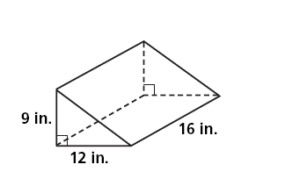  c  Draw the NET and label the dimensions: | Hypotenuse of Triangle, c =  _______________________________  SA = ________________________________  Volume =____________________________
5. Using the values below, calculate the requested measurements. Show your work/formulas for credit.  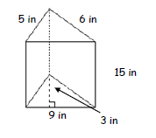  Draw the NET and label the dimensions: | SA = ________________________________  Volume =____________________________
Homework:
1. What would the Surface Area of the following Net Be? What about Volume?
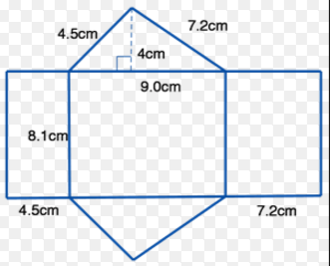

2. If the volume of the given shape is approximately 200 in³. What is the missing side length?
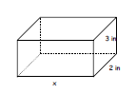

What if the area was approximately 315 in²? What would the side length be? Is it possible to determine this?

3. What would the Surface Area of the Composite Figure below be? The Volume?

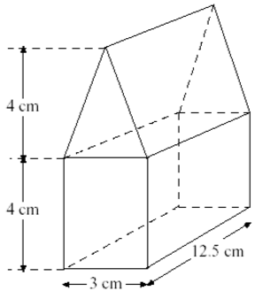

CHALLENGE:
